

How To Install Pop!_OS Linux Hands-On

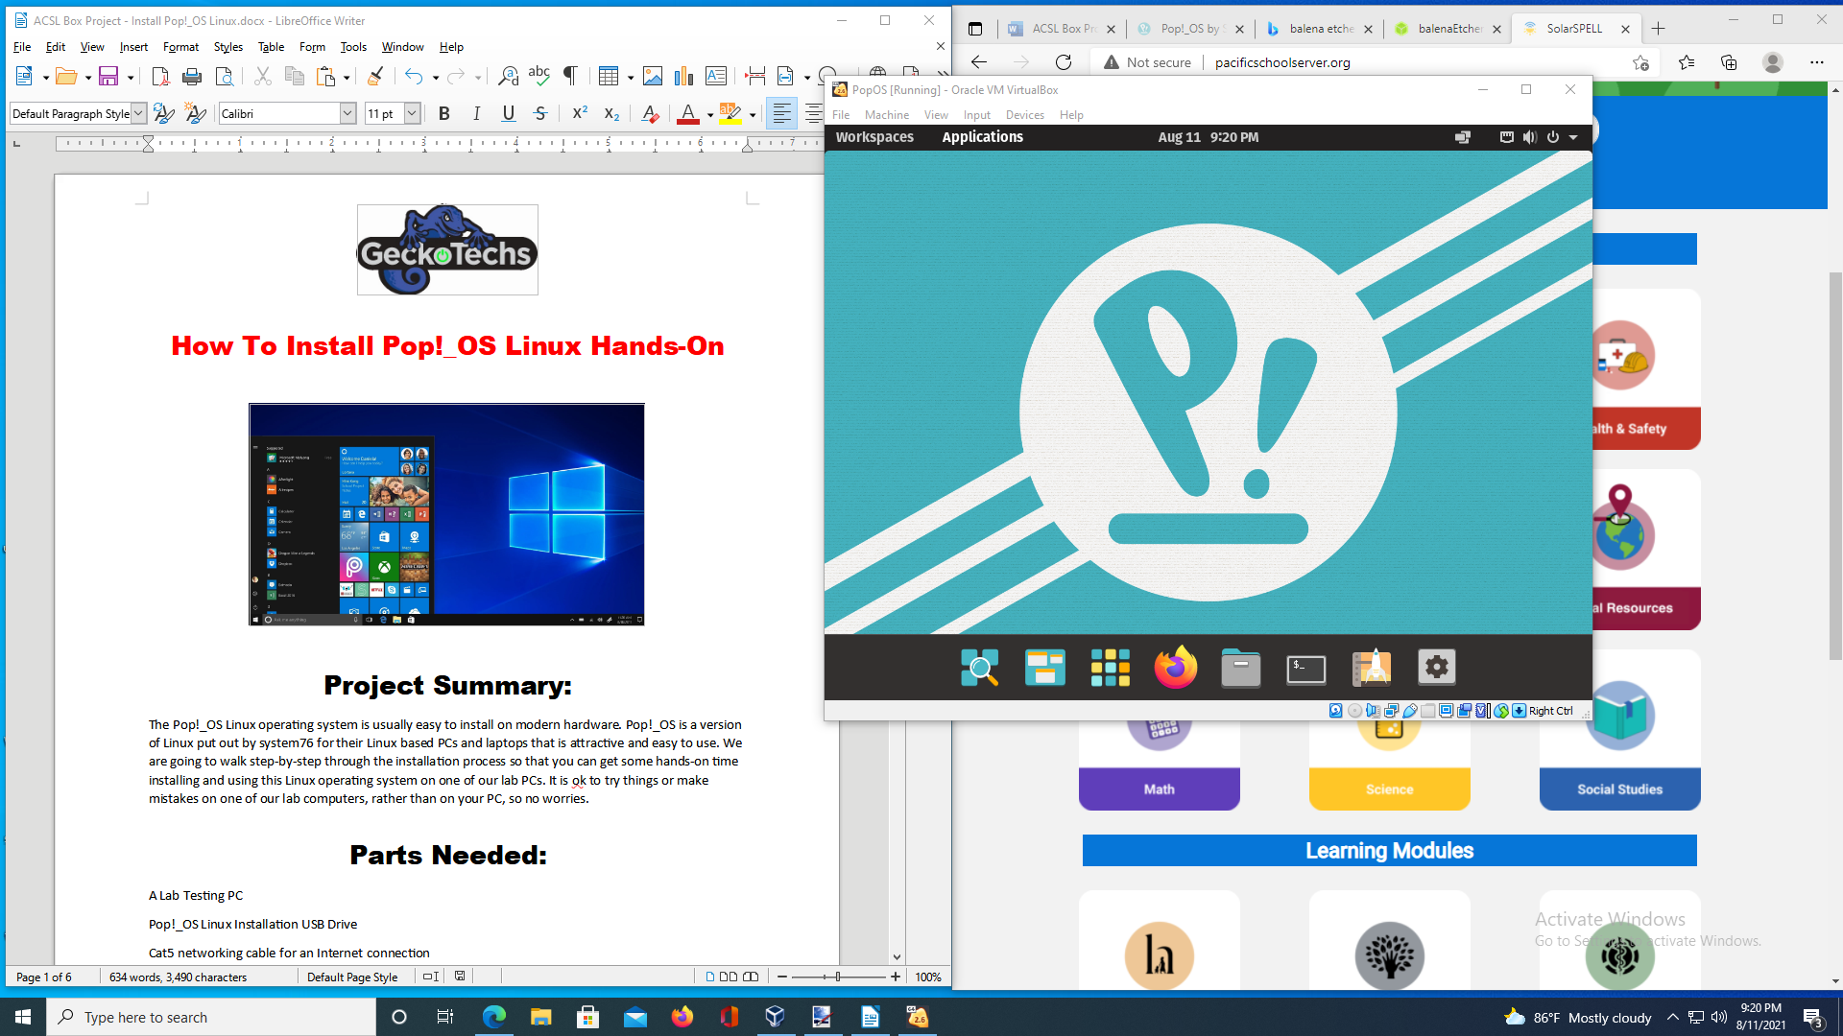

Project Summary:

The Pop!_OS Linux operating system is usually easy to install on modern hardware. Pop!_OS is a version of Linux put out by system76 for their Linux based PCs and laptops that is attractive and easy to use. We are going to walk step-by-step through the installation process so that you can get some hands-on time installing and using this Linux operating system on one of our lab PCs. It is ok to try things or make mistakes on one of our lab computers, rather than on your PC, so no worries.

Parts Needed:

A Lab Testing PC

Pop!_OS Linux Installation USB Drive

Cat5 networking cable for an Internet connection

Step-by-Step Directions:

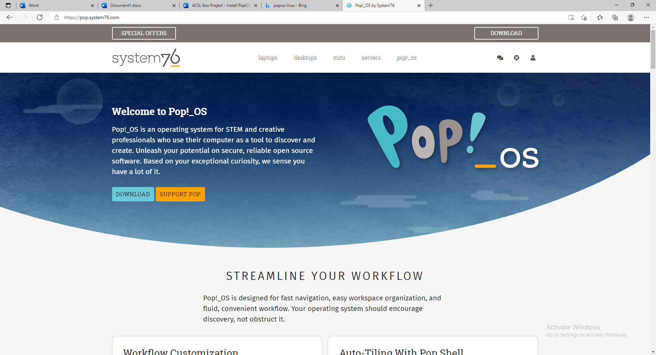

If you do not have a Pop!_OS Installation USB drive, it is easy to make one. Balena Etcher <https://www.balena.io/etcher/> is a tool that will install the data needed to a USB drive. The latest ISO file can be downloaded here: <https://pop.system76.com/> If you are in Gatway’s Advance Cyber Systems Lab, you are welcome to use our pre-configured USB drive for lab activities.

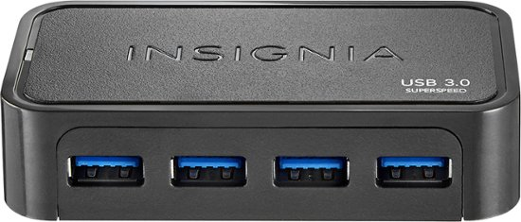

First, plug the USB flash drive with Pop!_OS into a USB port on the computer that is going to get a new operating system.

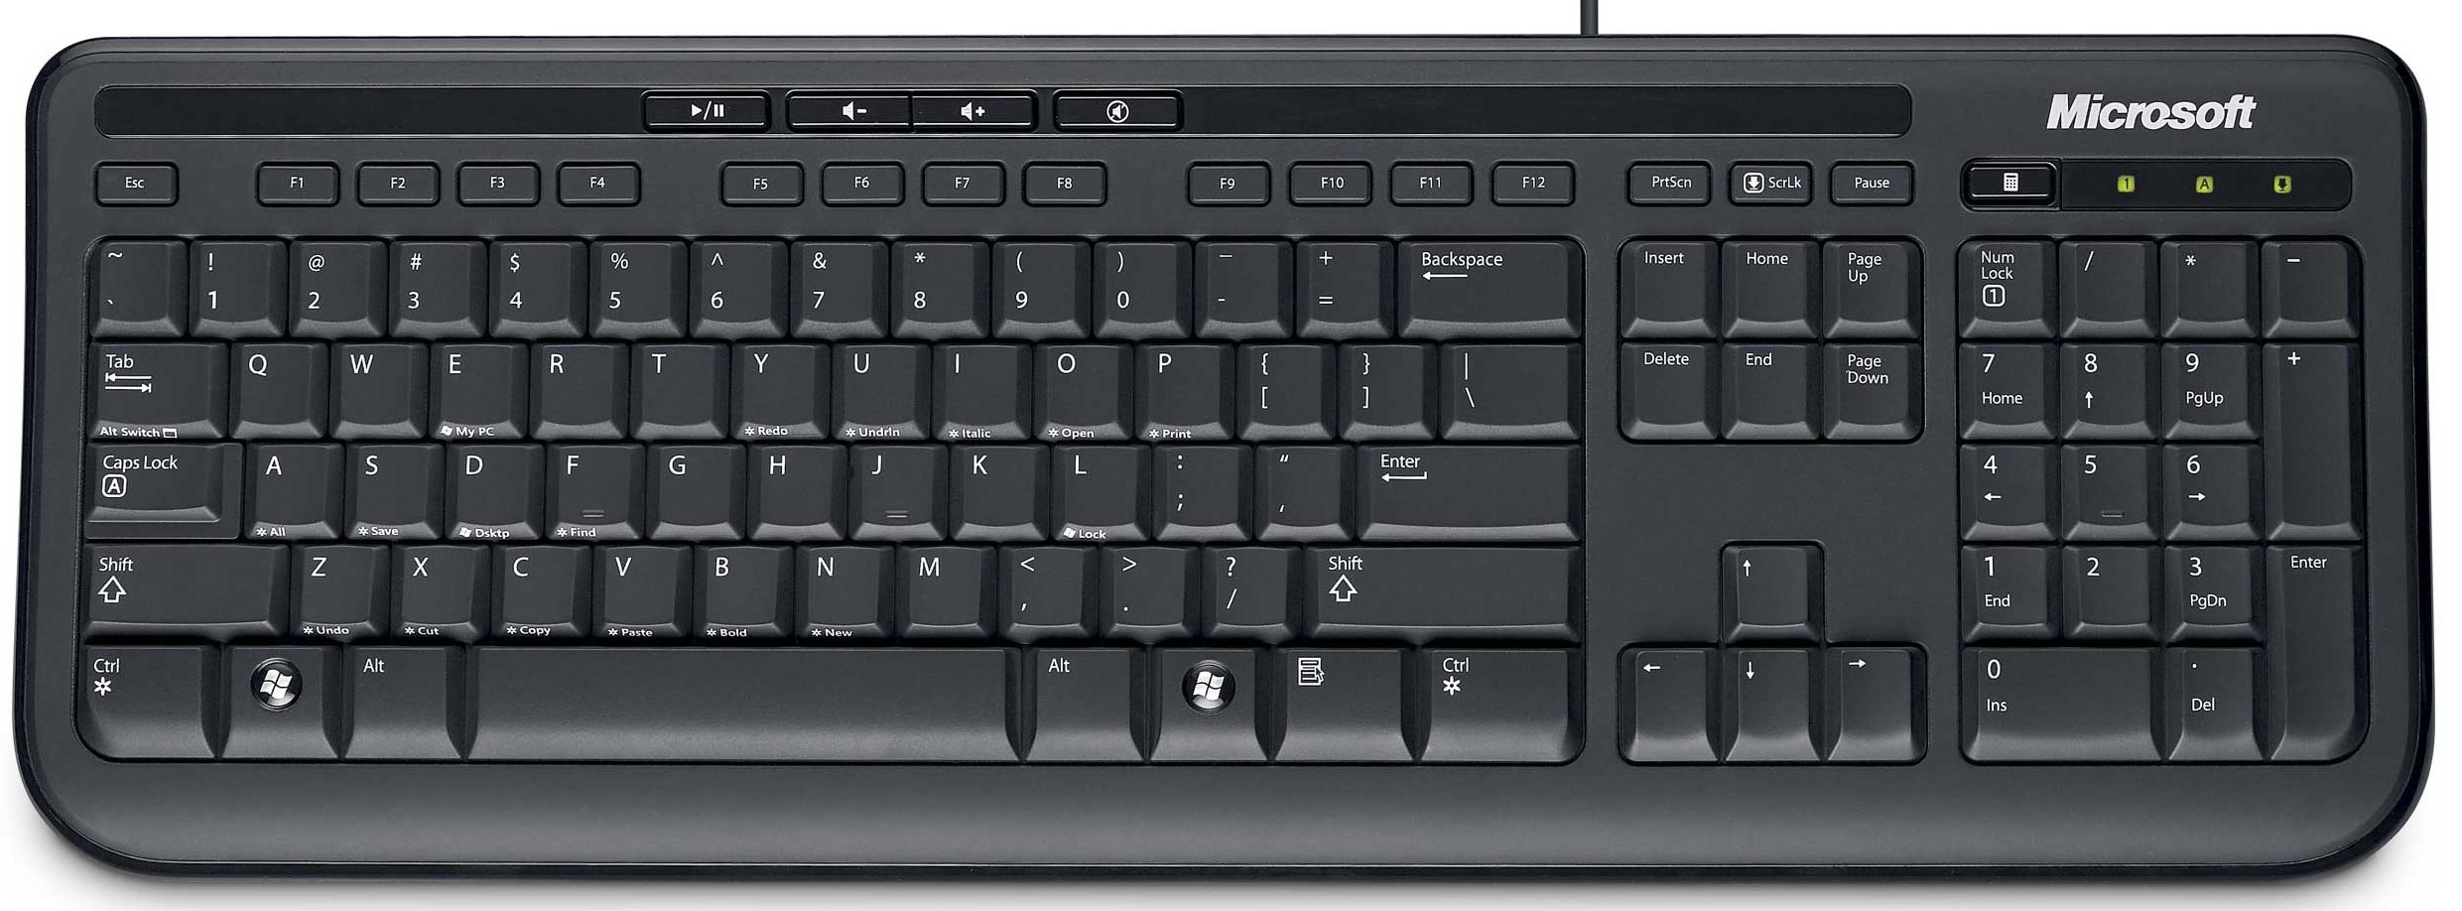

On most computers, we need to hit a key while the computer is booting up to get to the boot device menu. This is how we tell the PC to look at the USB flash drive instead of running whatever is on the hard drive. The common keys are **Esc** or **F10** or **F12** but some machines will use something different, so a bit of web searching with the model of the PC might be needed.

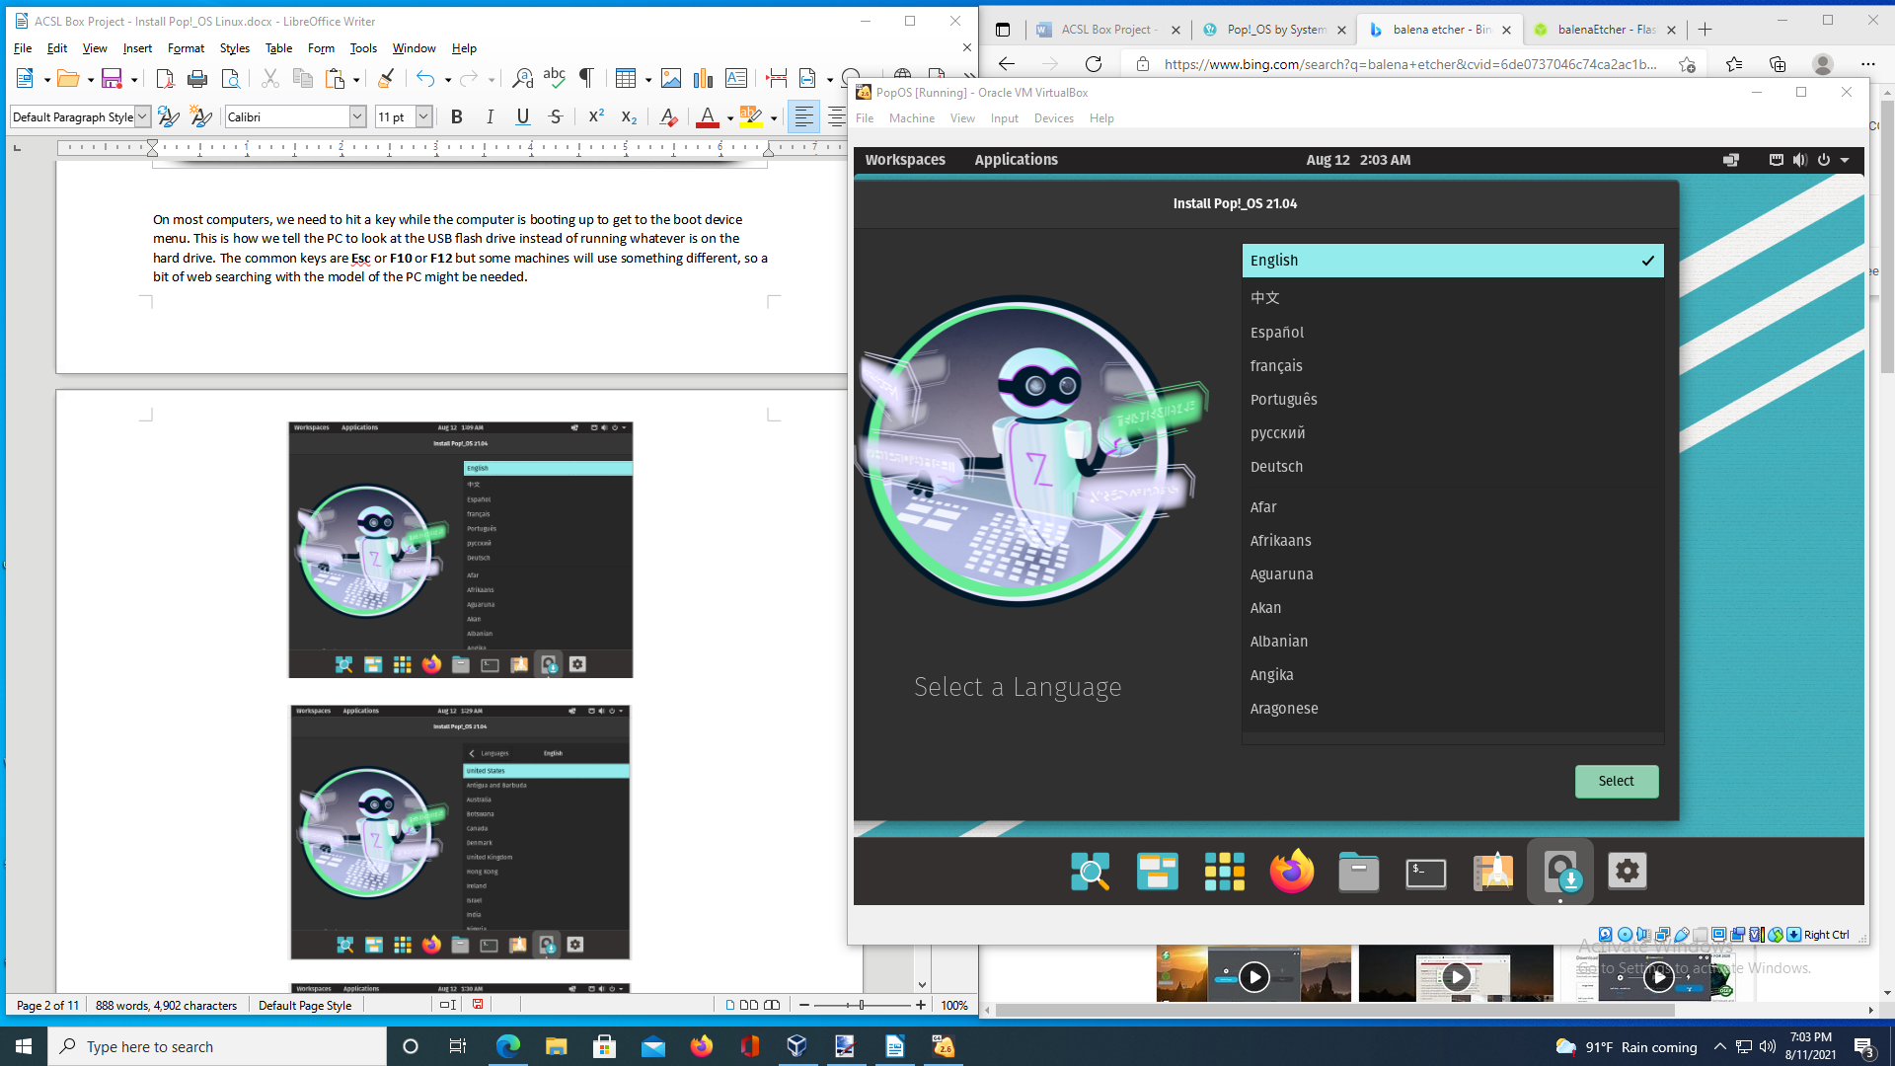

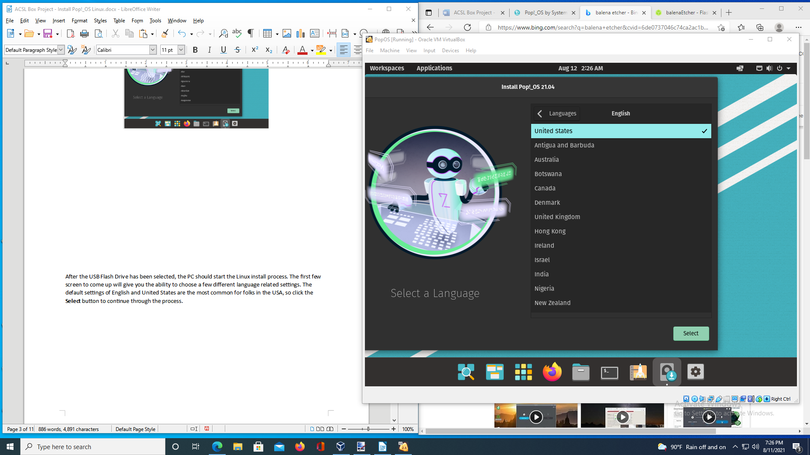

After the USB Flash Drive has been selected, the PC should start the Linux install process. The first few screen to come up will give you the ability to choose a few different language related settings. The default settings of English and United States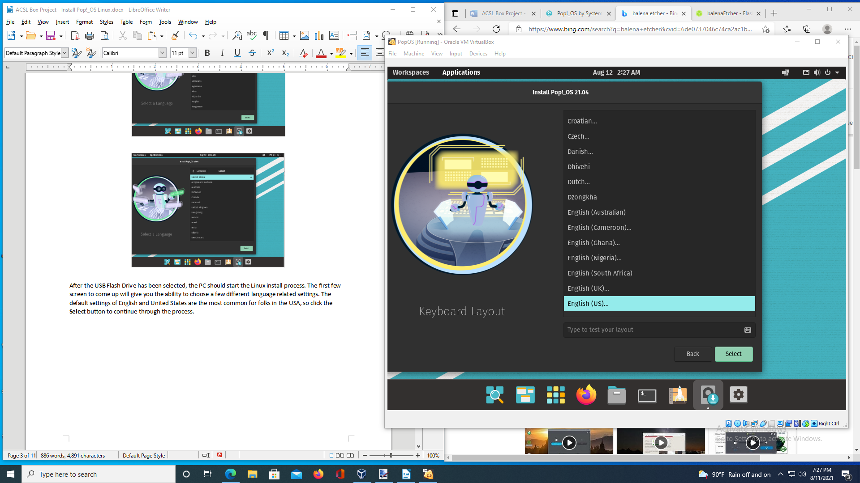 are the most common for folks in the USA, so click the **Select** buttonto continue through the process.

Input Language is asking what kind of keyboard layout will be used. As before, “default” is the best choice for a standard keyboard layout, so let’s select that and hit the **Select** key again to continue.

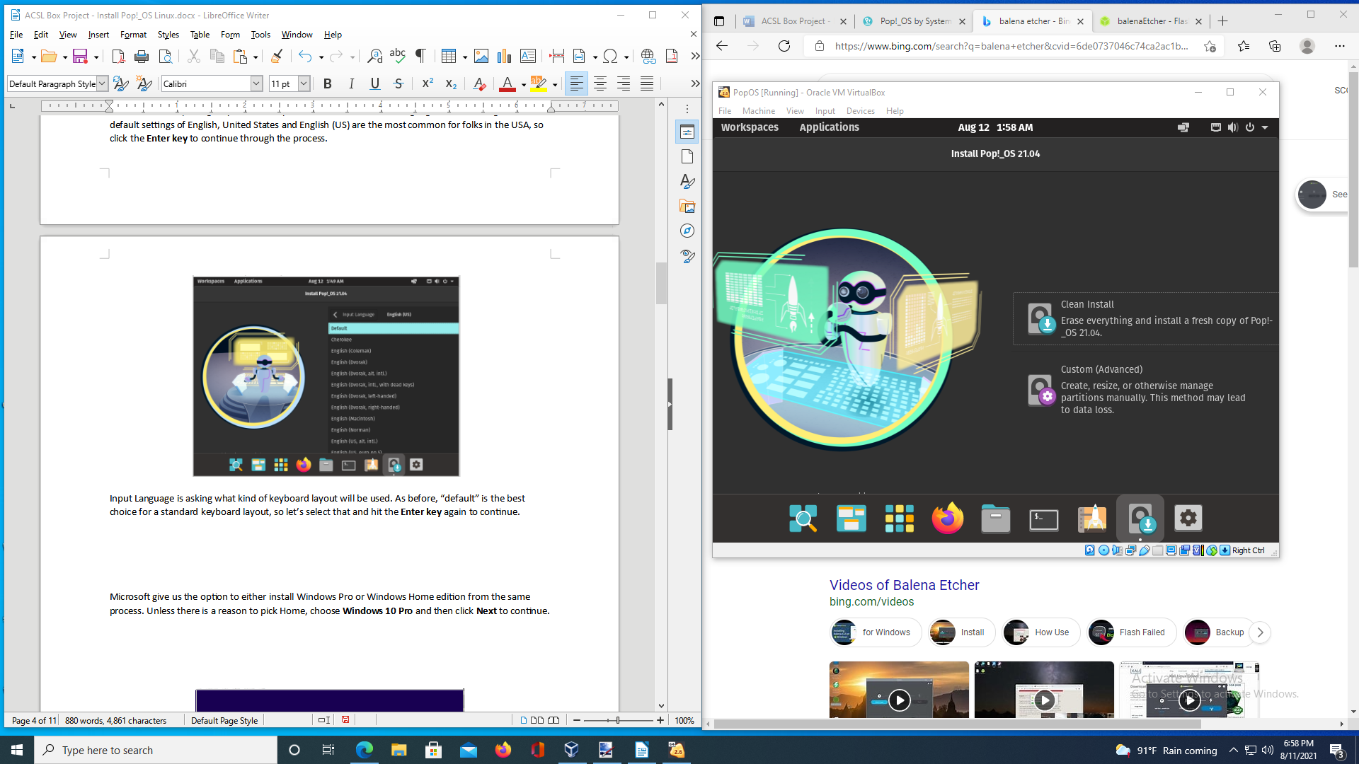

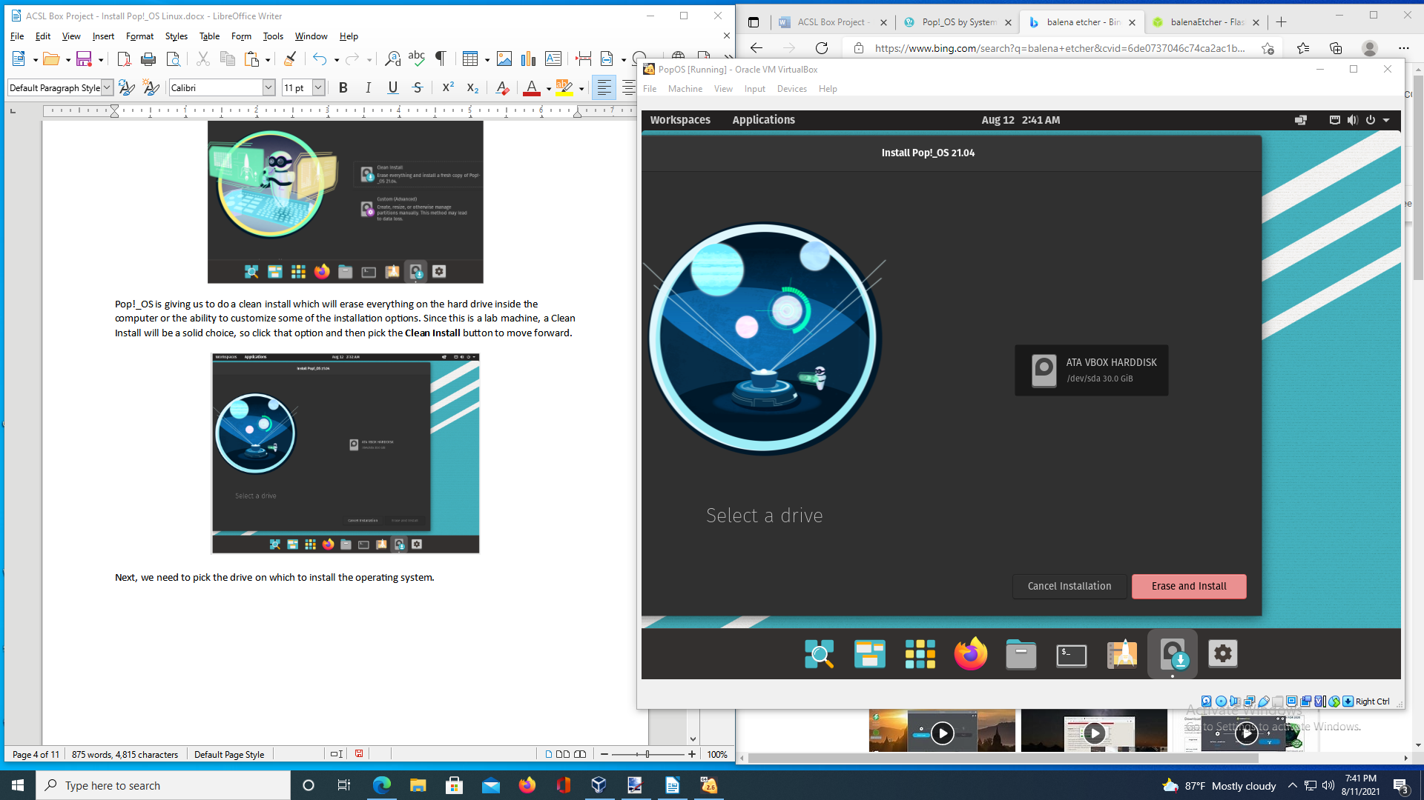Pop!_OS is giving us to do a clean install which will erase everything on the hard drive inside the computer or the ability to customize some of the installation options. Since this is a lab machine, a Clean Install will be a solid choice, so click that option and then pick the **Clean Install** button to move forward.

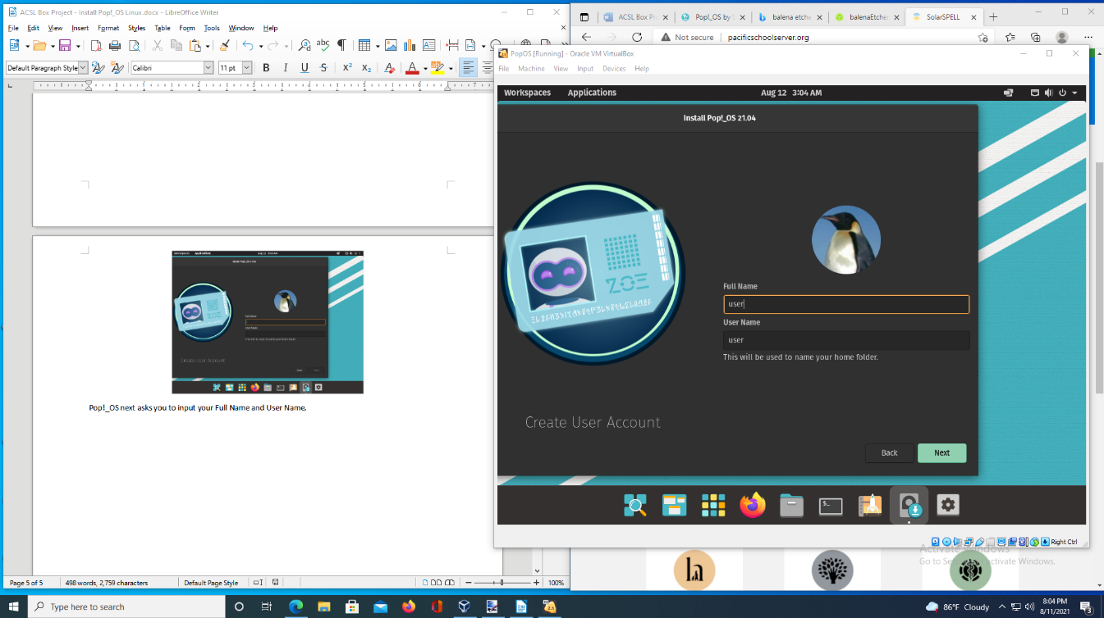  
Next, we need to pick the drive on which to install the operating system. Unless the computer you are using has multiple drives installed, there will most likely only be one option. So, click on the drive you want and then click on the Erase and Install button.  
  
  
  
  
  
  
  
  
  
  
  
  
  
  
Pop!_OS next asks you to input your Full Name and User Name. I’m just going to put “user” for both since this is a test install, but feel free to try something else if you’d like.

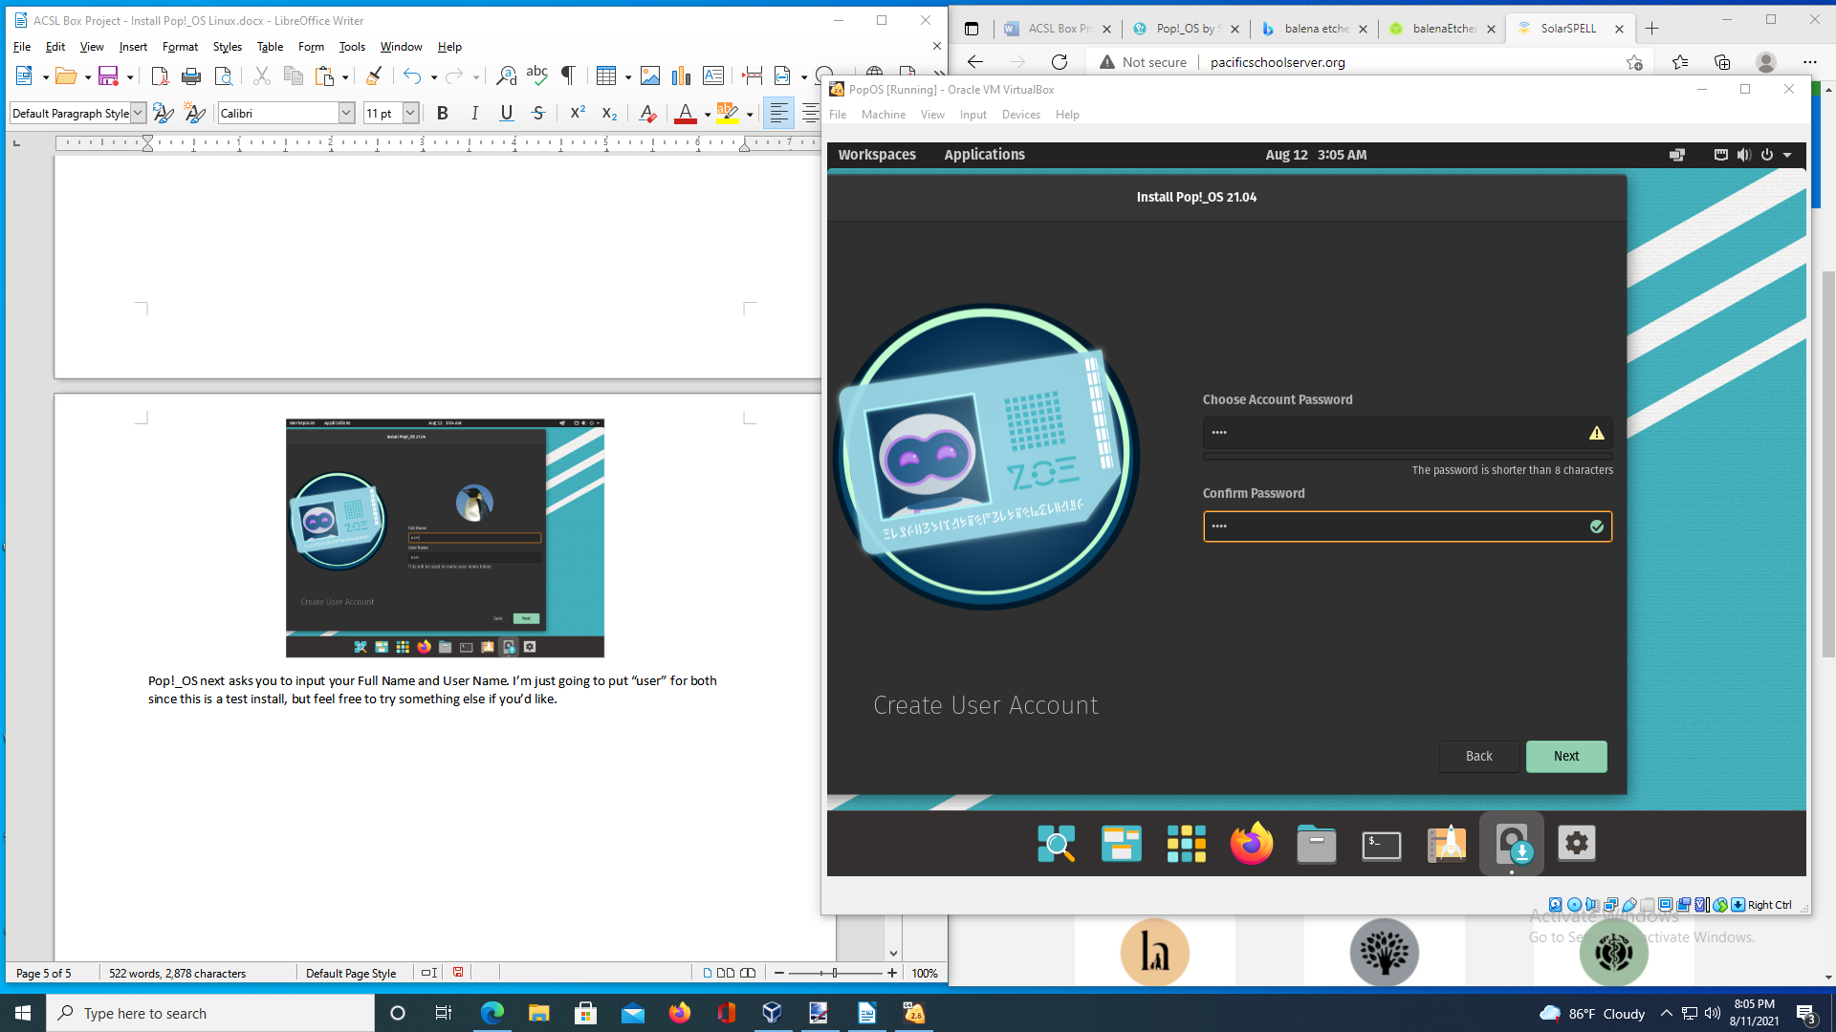

You will need to enter the password twice to help avoid problematic typos. If you pick a password that is shorter than eight characters in length, Pop!_OS will warn you that this is a poor security decision, but will let you make that choice if you insist. So, pick a good long passphrase by combining three random words to make a memorable long string and click **Next** to continue.

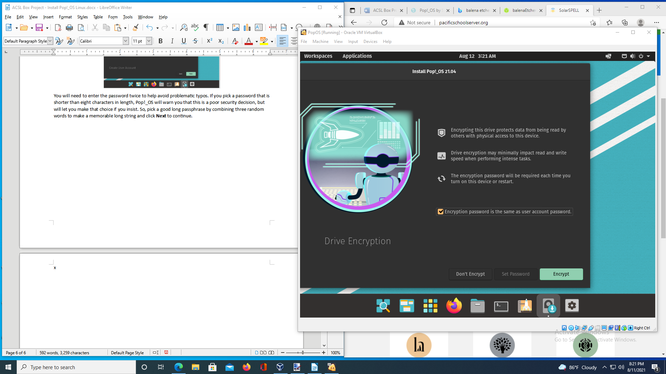

Click the checkbox to use the same password to encrypt and log into the machine and click **Encrypt**.

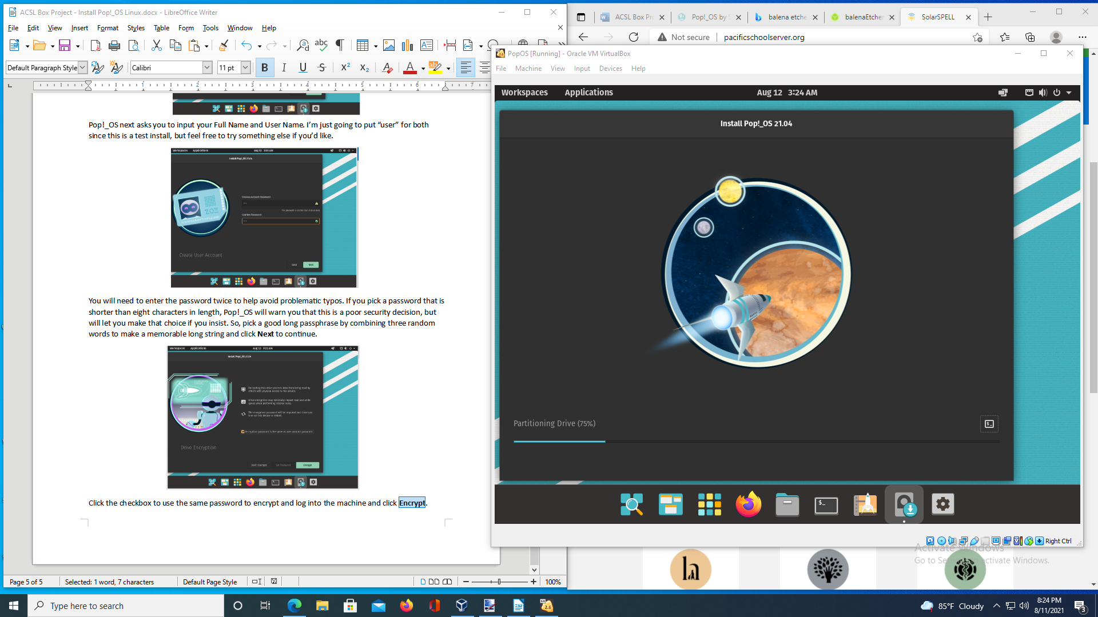

Now we just have to wait a few minutes for the installation to complete and we’ll be ready to run Pop!_OS Linux on our computer.